CSS
<!doctype html>
<html lang="en">
<head>
<meta charset="UTF-8" />
<meta name="viewport" content="width=device-width, initial-scale=1.0" />
<title>Units</title>
<style>
p {
/* font-size: 32px; */
/* font-size: 5cm; */
/* font-size: 20mm; */
/* font-size: 1in; */
/* 1in -> 96px */
/* font-size: 12pt; */
/* font-size: 2pc; */
/* fixed on all screen devices */
/* text-align: justify; */
/* word-spacing: 40px; */
/* letter-spacing: 20px; */
/* line-height: 50px; */
text-indent: 90px;
}

div {
/* width: 25%;
height: 100px; */
background-color: yellow;
font-size: 40px;
width: 100px;

/* vw => viewport width */
height: 100vh;
}
html {
font-size: 30px;
}

span {
font-size: 2rem;
width: 2em;
/* root element */
color: red;
}
h1 , a {
text-align: center;
/* text-decoration: underline; */
/* text-decoration: overline; */
text-decoration: none;
/* text-transform: uppercase; */
/* text-transform: lowercase; */
text-transform:capitalize ;
text-shadow: 10px 10px 10px yellow;
}

</style>
</head>
<body>
<a href="">Hello</a>
<!-- browser has user agent stylesheet inbuild -->

<h1>units</h1>
<del>Hello</del>
<p>Units</p>

<!-- container -->
<div>
<span>Em element example </span>
</div>
<!-- <p>Hello</p> -->
<!-- 16 px -->

<p>
Lorem ipsum dolor sit amet consectetur adipisicing elit. Quos
reprehenderit optio eveniet doloribus corrupti, illum adipisci ducimus
aliquid omnis magni veniam eos accusantium rem amet asperiores quam natus,
alias sunt.
</p>
</body>
</html>

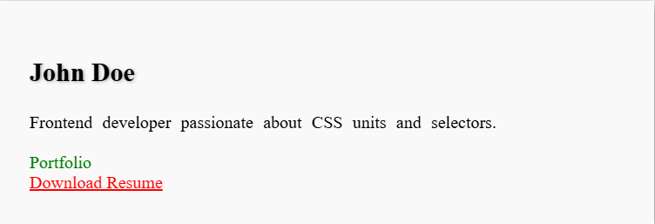

CSS Units
- Create three <p> elements and style each with different font units: px, em, and rem. Compare how they behave when you change the root font size.
- Make a <div> that is 50vw wide and 50vh tall. Resize the browser window and observe how it changes.
- Style a heading using absolute units (cm, mm, in, pt, pc). Compare across different screen sizes.
- Create a container with width: 50% and another with width: 200px. Compare how they behave when resizing the window.

🎯 Text Properties
- Create three headings and apply uppercase, lowercase, and capitalize using text-transform.
- Style links with underline, overline, and line-through using text-decoration.
- Write a paragraph and apply word-spacing: 20px, letter-spacing: 10px, and line-height: 2. Observe readability changes.
- Add a text-shadow to a heading. Then add multiple shadows separated by commas.

🎯 Selectors
- Style all <p> tags with blue text using a type selector.
- Style an element with id="special" using an ID selector.
- Style elements with class="highlight" using a class selector.
- Use an attribute selector to style all <input type="text"> with a border.

🎯 Combinators
- Use a descendant selector (div p) to style only <p> inside <div>.
- Use a child selector (div > p) to style direct child <p> of <div>.
- Use an adjacent sibling selector (h1 + p) to style the first <p> immediately after <h1>.
- Use a general sibling selector (h1 ~ p) to style all <p> after <h1>.

